Submitting Availability for USAWP
- Each Sunday, go to scafwp.org and fill out the availability form. You are submitting your availability for the following weekend.
- For a more detailed description of “submitting availability” follow the directions below:
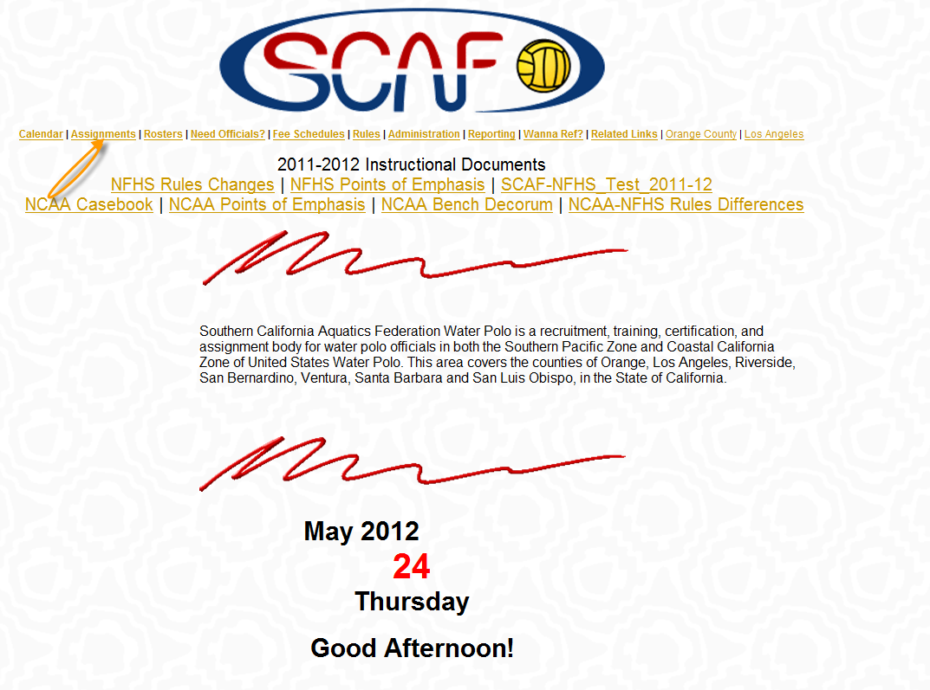
- Go to Scafwp.org and hit Assignments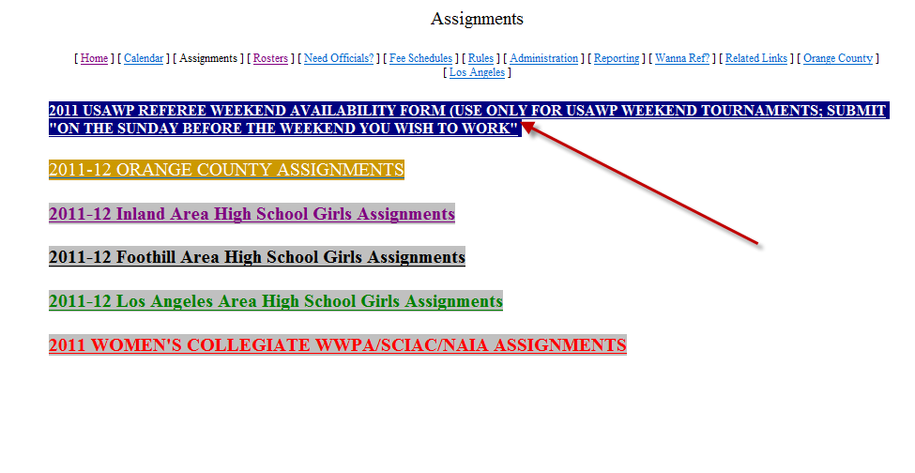
- Click on 2011 USAWP REFERREE WEEKEND
- Fill out the Google Doc that comes up.
- This should be done the Sunday before the weekend you would like to work

